
Loyalty Tri-V Umph
Cooperation October 2008
Friendship

President-J. Clingerman-248-788-1378 Sec.-D. Angelosanto-734-422-3501
V. President-M.Trachsel-586-484-0836 Treas.-G. Steinhauer-734-459-4471

President’s Message

As we say goodbye (hopefully) to the hurricane season and hello to colorful leaves and Halloween, October begins. I know you are getting tired me saying how much I love each month/season, but there is something special about each one. This truly is my favorite month. I love the changing of the leaves, cooler weather, and of course my favorite spectator sport - football. Several of us are trying to make our fantasy football team stronger each week by dropping and picking up players we never heard of. If you haven't gone apple picking this year, you still have a few weeks until they are all gone. It is a really fun experience for young and old. And really the donuts are what I go for.

Last month Mike Trachsel and the council proposed and had approved the 2009 budget. They introduced a new activity, Easter egg hunt, which should bring a lot of joy to may of our kids and grandchildren.

This month I will assign members to the 2009 committees (attached to the new letter). Since I only heard from a couple of you regarding what committee you wanted to be on, I will accept no complaints. Well, I guess you can complain, but it won’t do any good.

Your Pres,
John C.

Wives Club Meeting

The next meeting for Tri-V Wives has been rescheduled to Oct. 22. The meeting starts at 7:00 pm and will be held at Jan Cashman's home. All women of Tri-V are invited--wives, girlfriends, significant others, etc. The November meeting for Tri-V Wives will be held at Judy Lardin's on Nov. 19 at 7:00 pm. The December meeting for Tri-V Wives will be held on Dec. 17--location and time TBD..

Book Club

The next Book Club meeting will be held at Jacqui Schaefer's on Monday, Oct. 20 at 7:00 pm. The book we are discussing is "The Emancipator's Wife" by Barbara Hambey.

All women of TRI-V and their friends and or neighbors are invited to join us in discussing the books that we've read. If you've read a book that you think would be a good book for discussion, please let one of the regular members know.

The Book Club meeting that was scheduled for Oct. 6 has been cancelled.

October Event

The committee has planned Feather Bowling at the Cadieux Cafe, on Saturday, October 18, 2008 for 5:00 pm. This event started out as the Stag event, but because of minimal interest, it is now open to members, prospectives and their significant others. The plan is to bowl from 5 to 6 pm. and have dinner after bowling. I have rented both alleys which will be paid by the club. Dinner and drinks will be at your own expense. Some members committed to the event at the September meeting, but since it is now open to our significant others, I will need a new count. If you are going to attend the event, you can let the committee know at the October meeting, by calling, or by email . We need to give the Cadieux Cafe a count for dinners.

Your committee,
Ken Stress
Mike Lardin

November Social

This year the November Social will be held on Sunday, November 2nd at 3PM at Three Cedars Farm in Northville. We will be enjoying the outdoors and remembering that this area used to be a lot of farm country, WOW, what happened. At the farm, there is a play area for the children, a donut hut where cider (cold or hot) and donuts (plain or cinnamon-sugar) will be available. For the ladies, there is a country store with all kinds of the fun decorative items for the house around the holidays. Then we are all going to enjoy a corn maze and hay ride. For those with allergies, there is not an option for no hay, but it is bundled and not loose. This hay ride will take us to our very own bonfire. There we will close out the evening and share as only Tri-V families can. Either dinner or smores will be provided by the club. The cost will be $10 per adult and $5 for the children. It would be appreciated if a rough count can be collected at the meeting. The address is: 7897 Six Mile Road, Northville, MI 48167

Children’s Christmas Party
Please mark your calendars for Sunday December 7th, at 2:00 pm. The Children’s Christmas party will be held at the Colonial Acres clubhouse in South Lyon. We need to have a count for adults and children that plan to attend by the Men’s Club meeting on November 12th. Adults please bring a gift for each child who will be attending with you for Santa to give out. We ask the price be kept to under $20. More details to follow in next months Umph. Your committee – Tim Gies, Jay Trachsel & Curt Martin.

Tri-V Pinochle Schedule 2008-09

Over the years Tri-V has adapted to better serve it’s membership. Pinochle is now going through a change. It has been noted that everyone doesn’t like having a second night of pinochle (sometimes) scheduled to accommodate our many diverse schedules. We would ask everyone to mark the first Saturday of every month and try to keep it open for pinochle, but we know that isn’t always possible. Once, or twice pinochle will have one house play on a different more convenient night. There will even be one pinochle night held in Florida – not much different than Florida having it’s own Anniversary Party. If we all remember that pinochle is FIRST a social event and a card competition second we should then be happy that everyone was able to enjoy an evening of friends, food and cards.
It is becoming increasingly harder to have three homes playing at the same time. Sometimes change is necessary. Your committee hopes you enjoy this season of cards.
Nov. 1
CASHMAN CLINGERMAN WUTKA
N. Angelosanto Stress Barnes
Mackson B. Trachsel Massoll/Forsyth
Jeff Trachsel B. Kuhr/McMillan Connolly
Schaefer D. Angelosanto Gies
Steinhauer M. Lardin J. Lardin
J. Gies

Dec. 6
BARNES SCHAEFER FORSYTH/MASSOLL
T. Gies Connolly Mackson
Clingerman B. Trachsel J. Gies
Kuhr Jeff Trachsel N. Angelosanto
M. Lardin Stress D. Angelosanto
Cashman Wutka J. Lardin
Steinhauer

Jan. 3
J. LARDIN M. LARDIN STEINHAUER

Jan. 31 (this home only) Feb. 7
N. Angelosanto K. Stress ?

March 7
Mackson B. Trachsel ?

IF YOU NEED TO CANCEL CALL NICK OR JEFF T. IT IS NOT THE HOST RESPONSIBILITY TO FIND A SUB.
Trifles

From the G. Hoffmans

We will be leaving for Florida on Oct 10.... Our plans have changed and we will NOT be going to Reno and shall return to the Detroit area in the spring instead of July....Right Now... (subject to change... again)

From the J. Lardins

We are happy to report that John Lardin has completed successfully his 36 rehab visits from his heart attack and his last appointment at the heart Doctor on October 1st he was given a clean bill of health and no need to return for six months. Now that rehab is done he is once again starting to work on a program to lose some weight. He has shown some progress and at the last visit to his primary physician was given a little lea way and does not have to return for two months instead monthly. John is expected to walk for 30 minutes a day and ride his bike for 30 minutes a day. This is assuming that he is not having rehab with Jack Schaefer and George Hoffman on the golf course. If so then it would be just the bike ride. Jack or John can tell you the story about that. Speaking of doctors, Judy Lardin had to switch her primary physician as the one she had went into handling sports medicine at Garden City Hospital and after checking settled on the same one John has. After reading the results of her blood work he told her all was good and she was on the right track. John had to tell him “I’m taking pretty good care of her.” He looked at them and answered “I will not comment on that.” As you read this the Andersons, Connollys, Lardins and Schaefers will be in Branson Missouri enjoying a five day trip. The trip will take by train from Dearborn to St. Louis Missouri then motor coach to Branson and returning by train from Springfield Illinois to Dearborn. All are excited and looking forward to the time together. Upon the return from Branson, Judy and John will once again make a trip to Corpus Christi Texas to celebrate Christine’s fourth birthday. They will leave on Friday and return on Monday or Tuesday. Hopefully the weather will have cooled down some, maybe only in the mid 80s, and Judy will not bring another hurricane to Texas. On her last three trips in August she had to leave early or was stuck there because of hurricanes.

From the Dusharys
Kathie and I will be driving down to our condo at On Top of The World in Ocala, FL on Oct. 17th and will stay there through most of May, except for a brief trip back during the holidays. Our land phone will be disconnected. Our cell phone numbers are: 989.388.6487-Art and 989.763.2454-Kathie. Our daughter, Nicole, and her family recently moved from Lansing to Hastings where Joe started a new job. They got caught up in the housing fiasco with a change in payments and a home now valued at 2/3 of their mortgage. Our 7 year old grandson, Bradley, broke his arm and wrist while showing off to "his ladies"(that's what he calls his girl friends). He jumped off the top of a slide and the trick didn't work as planned. We hope many of our TRI-V friends will stop by for a visit. We are only 8 miles off of I-75. Take Care

From the Richeson’s Daughter, Leanne

Sept 17--Just wanted to let you know that Dad fell again on Friday. He broke his femur (by hip). He is at Beaumont Hospital Royal Oak. Had surgery this a.m. to repair break and is back to his room. We will see how he does with recovery/rehab. You may pass this on since I only had a few email addresses. I will try to keep you updated. Sat 24--Wanted to let you know that they transported Dad back to Presbyterian Village from the hospital on Friday. However, he is not doing well. He has fluid in both lungs and pneumonia in upper right lobe. They may be sending him back to the hospital later. Thank you for your continued prayers. Sat 28--Dad was taken back to Beaumont Hospital again on Saturday night. They have put him on a third antibiotic and are running further tests. He seemed a bit better when I visited on Sunday. Dr. Ellens (my minister) met me there after we left church and we sang some of the old hymns. Dad really seemed to enjoy that. Dad was not doing as well today. It seems to calm him when I'm there, so I stayed for about 3 hours today. Dave usually goes on his way home from work each day. Thank you again for your wonderful prayers. I just want Dad to be peaceful. Oct. 6--Just wanted to let you know that our Dad is in hospice care now. The doctor has indicated that it may just be a matter of hours or at the most a few days. Thank you for all your continued prayers.
Love, Leanne

From the Wendts

This is the 1st year we have spent the whole winter in Fl. and it wasn't bad. Now we are waiting for our friends to get back from the North Country. Especially looking forward to our annual visit with the Suchners. Peg is feeling better she don't get so dizzy anymore and we found an eye Dr. that is helping her double vision. Bob's bone cancer is being treated. Instead of chemo I opted for a drug called quadramet it is a radiation that keeps the pain down and keeps the bones from breaking.

From the Cashmans
Cal & I attended my 45th high school class reunion on September 27th in Wilmot, Ohio (Amish country). We left for Ohio on September 24th to visit with my Mother for a few days prior to the reunion to help her with anything she needed to have completed. There are always a few jobs she has in mind for us! We had a wonderful time at the reunion and it was so nice to see some of my classmates again and catch up with their busy lives. We stayed at a beautiful Inn in Wilmot with the Ohio countryside as our scenery. On October 11th we will be attending Cal's 50th high school reunion in Troy so I am sure Cal will have just as good a time as I did catching up with classmates. We celebrated our 19th wedding anniversary September 30 by going to a great restaurant in Union Lake called "It’s a Matter of Taste". The food was excellent and as we were finishing our dessert the sun was setting over Union Lake. What a beautiful sight to see and a great way to end the evening.

From the Bill Trachsels
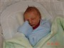
Bill and Michelle Trachsel are excited to announce the arrival of their second child; Joseph William. Joey was born on September 27th at 3:35 pm. He was 21" long and weighed 6lbs. 15oz. at birth. Big sister Julia was so excited to finally meet her baby brother. She has handled the change well, and has been a very willing helper. The family came home on the 28th and everyone is adjusting well.
From the Brian Trachsels
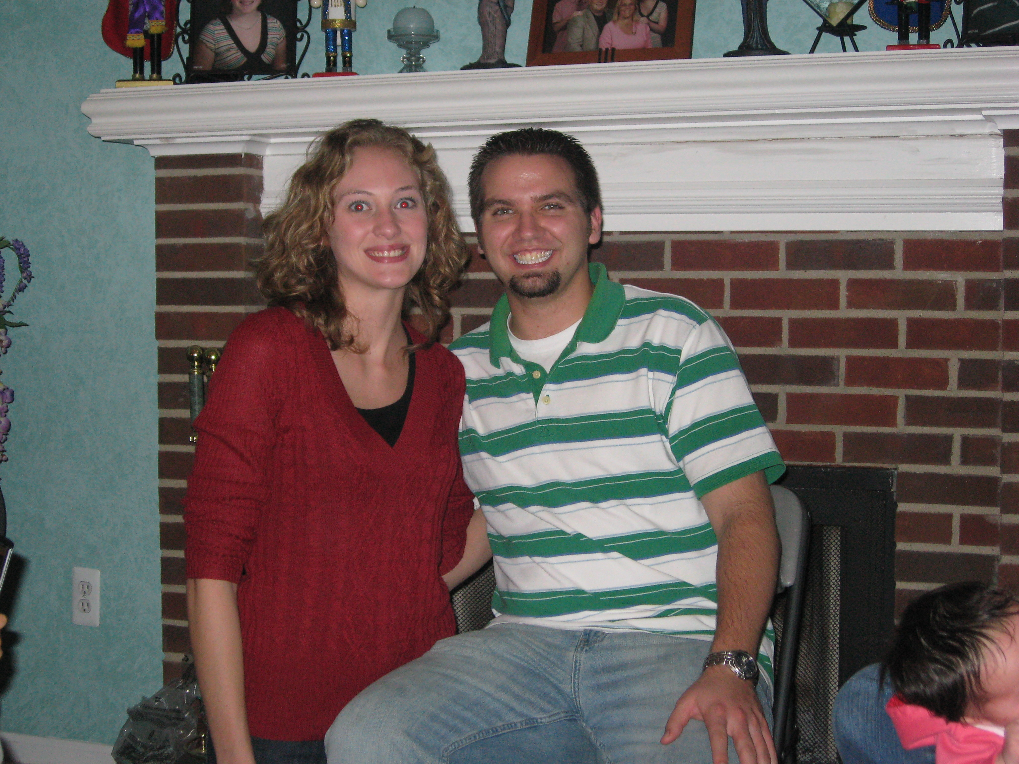
Brian and Jane Trachsel announce the engagement of their daughter, Kimberly to Prospective Member, David Burke. Wedding details are still in the process of being planned.

Calendar of Events

October November
4th Pinochle starts 1st Pinochle
8th Men’s Club Mtg.(Walkers) 2nd November Social(Three Cedars Farm)
18th Feather Bowing (Cadieux Café) 12th Men’s Club Mtg. (Walkers)
20th Book Club(J. Schaefer) 19th Wives’ Club Mtg. (J. Lardin)
22nd Wives Club (J. Cashman)

October Birthdays November Birthdays
6th Robyn Mackson 3rd Betty Galloway
8th Delores McMillan 5th Jacqui Schaefer
15th Don Winters 6th Dennis Wutka
8th Ken Plocharczyk
10th Brett Barnes
23rd Jeff Trachsel
24th Karen Thrift & Blondie Forsyth
26th William Trachsel
29th Christine Hoffman

October Anniversaries November Anniversaries
10-19-68 Jack & Jacqui Schaefer 11-20-05 Curt & Susanne Martin
10-24-87 Brett & Lynne Barnes 11-23-?? John & Donna Clingerman
10-25-58 Dennis & Marlene Wutka

MEMORIES FROM THE OCTOBER 1998 ISSUE OF TRI-V UMPH

The October 1998 issue was a small issue with very little to report. Our prayers went out to Lu Wagner who had a hernia repaired the end of September and Lorraine Trachsel’s 99 year old mother who was suffering from a horizontal as well as a vertical break in her hip. The September Stag was an evening of dinner and Whirly Ball and was attended by 10 Club Members. Tri- V Members and their family members were busy with various trips reported. Pat Foley flew down to Charlotte, N.C., the end of September to stay with his teenage grandchildren while their parents went to California and Hawaii and Art Trachsel flew to Sioux Falls, S.D. the end of September to appear as a character witness for his son Kirk for an injury law suit. Cindy Todd was moving to Orlando, Florida to begin new duties supporting the Campus Crusade she has been involved with and the southward trek to Florida began with the both Trachsels, Reids, Richesons, Wendts, Massolls, both Suchners, Winters and Gasco gone for the winter. Betty Galloway was celebrating the birth of new granddaughter McKenna Rae and Gret5chen Dunham and been running in a few 5K races during the summer and came in third in a South Lyon race.

MEMORIES FROM THE OCTOBER 2003 ISSUE OF TRI-V UMPH

As we look back on the past issues and mention those in need of our prayers we were happy to report that though still in need of our prayers, Lorraine Trachsel was no longer using a walker and the swelling and cellulites in her legs had cleared up even though she tires easily. Peg Wendt was staying with Art and Kathie Dushary in their Lansing Area home as Peg continued to make progress and she also was tiring easily. Ray Suchner was having difficulty seeing and the last treatment made it worse than better and after the swelling has gone down will make his trip to Florida for the winter and two members, Lu Wagner and Bill Jesse, were also in need of our prayers as both were hospitalized though we did not know the details. Details were furnished for the 2003 TRI-V Pinochle season with a handicap system being installed to try to level the playing field allowing all not to fall to the bottom of the pack or lose incentive with low scores and not wanting to do your best. Feather bowling was set for the afternoon of November 8th at Cadieux Café and a Christmas Choir program at Northville High School the evening of December 13th. Couples Final Golf was hosted by the Dusharys and Plocharczyks and attended by nine couples in the Lansing area. Monster Mash Glow Ball Golf was held at Fox Hills Golf Club on October 25th with dinner and glow ball golf following. Vickie Angelosanto, mother of Vickie Angelosanto, was returning to Mesa Arizona to get away from our cold Michigan winters and Jacquie and Jack Schaefer were celebrating the birth of their third granddaughter, Kaylie. Karlyn and Tim Gies spent a week in San Francisco enjoying the weather, food and many sights. Dennis and Marlene Wutka made a trip with the Redford Seniors to the Grand Casino, Gulfport, Mississippi and the group hit the $10,000 jackpot. After the federal and state got their share of the taxes the 46 happy travelers shared $152.17 each. What would the memories be if we failed to report that once again Judy and John took advantage of John’s job with Northwest Airlines and made a four day trip to San Antonio Texas to visit Kim and Larry. Mike went along with this trip and a couple rounds of golf were played, one of them at Lacentera, the same course the PGA played the week before they did. This wraps up another trip down memory lane. For those who might not remember, the Glow Ball Golf was originally scheduled for the October Social in 2001. The weather was iffy that year and we cancelled the event at the last minute. Mike Lardin took it upon himself to try to have this non-scheduled event this year and it was a success. The net winnings for the Wutka casino was $7,000 divided among those participating and each only contributed $20 for the chance. Karlyn Gies acquired a taste for Sake on their trip to San Francisco. Does she still have the same affection for Sake now?
Halloween will be here by the time you read this newsletter. Do you remember how you used to dress for this fun day? Did you get to wear a costume to school? Was Mom or Dad the one to take you out trick or treating? What about our own children or grandkids? Do you think they have as much fun as we did this time of year? Share the memories of what you did or what our children did and they probably do not remember. It is surprising when family members get together and start talking memories how often one or more will say “I don’t remember that.” or “Did I really do that?” Until next month when we see you in print, the Good Lord willing, take care of one another.

Tri-V Committee Assignments for 2009
Month | Event/Committee | Budgeted | Budget '08 | Chairman | Committee
J | Council Party | X | $300 | Vice President | Council
F | Winter Event |  | - | Steve T | Dion
M | Anniversary Party | X | $900 | Matt H | Brian T
 |  |  |  |  | Ken S
 |  |  |  |  | Mike L
 | Children's Easter Egg Hunt | X | $100 | William T | Jeff T
A | Final Pinochle | X | $150 | John M | Dave B
M | Open House |  | - | Nick A | Dick B
 |  |  |  |  | Eric H
J | Initiation | X | $25 | Tim G | John L
J | Picnic | X | $200 | Jerry G | Dave B
 |  |  |  |  | Jack S
 |  |  |  |  | Jay T
A | Roast (Steak) | X | $250 | Mike L | Ken S
 |  |  |  |  | Nick A
 |  |  |  |  | Brett B
 |  |  |  |  | Steve T
S | Final Golf | X | $175 | Matt V | John M
 |  |  |  |  | Geoff
 |  |  |  |  | Jeff T
O | October Event - Stag | X | $100 | Bob K | Jerry G
 |  |  |  |  | Jack S
 |  |  |  |  | Dennis W
N | November Event - Social | X | $100 | Eric H | Tim G
 |  |  |  |  | Mark E
 |  |  |  |  | Tom U
D | Christmas Party - Santa for Kids | X | $100 | Jay T | Bob K
 |  |  |  |  | Dave B
* | Florida Anniversary | X | $150 | Lee A | George
* | Newsletter | X | $608 | John L
* | Pinochle ('09-'10) |  | - | Brett B | Cal C
* | Golf |  | $0 | Tom | Romas
* | Bowling/Other |  | - | Romas | Dion A
 |  |  |  |  | Terry C
* | Nominations |  | - | Brian T | Matt H
* | Membership |  | - | Cal C | Matt V
* | Property |  | - | George H
* | Audit |  | - | Dick B
Total: Match Revenue |  |  | $3,158

